PROGRAM 8

a) INSERTION DELETION AND TRAVERSAL IN BINARY SEARCH TREE

#include <iostream>
#include <queue>
#include <vector>

struct Node {
int data;
Node* left;
Node* right;

Node(int val) : data(val), left(nullptr), right(nullptr) {}
};

class BST {
public:
Node* root;

BST() : root(nullptr) {}

// Function to insert a new node with given data
void insert(int data) {
root = insertRec(root, data);
}

// Function to delete a node with given data
void deleteNode(int data) {
root = deleteRec(root, data);
}

// Function to print the tree in array format
void printArray() {
std::vector<int> arr;
fillArray(root, arr);
std::cout << "Tree in array format: ";
for (int value : arr) {
std::cout << value << " ";
}
std::cout << std::endl;
}

// In-order traversal
void inOrder() {
std::cout << "In-order traversal: ";
inOrderRec(root);
std::cout << std::endl;
}

// Pre-order traversal
void preOrder() {
std::cout << "Pre-order traversal: ";
preOrderRec(root);
std::cout << std::endl;
}

// Post-order traversal
void postOrder() {
std::cout << "Post-order traversal: ";
postOrderRec(root);
std::cout << std::endl;
}

// Breadth-first search (BFS)
void bfs() {
std::cout << "Breadth-first search (BFS): ";
if (!root) return;

std::queue<Node*> q;
q.push(root);

while (!q.empty()) {
Node* current = q.front();
q.pop();
std::cout << current->data << " ";

if (current->left) q.push(current->left);
if (current->right) q.push(current->right);
}
std::cout << std::endl;
}

private:
Node* insertRec(Node* node, int data) {
if (!node) {
return new Node(data);
}
if (data < node->data) {
node->left = insertRec(node->left, data);
} else {
node->right = insertRec(node->right, data);
}
return node;
}

Node* deleteRec(Node* node, int data) {
if (!node) return node;

if (data < node->data) {
node->left = deleteRec(node->left, data);
} else if (data > node->data) {
node->right = deleteRec(node->right, data);
} else {
if (!node->left) {
Node* temp = node->right;
delete node;
return temp;
} else if (!node->right) {
Node* temp = node->left;
delete node;
return temp;
}
Node* temp = minValueNode(node->right);
node->data = temp->data;
node->right = deleteRec(node->right, temp->data);
}
return node;
}
Node* minValueNode(Node* node) {
Node* current = node;
while (current && current->left) {
current = current->left;
}
return current;
}

void fillArray(Node* node, std::vector<int>& arr) {
if (node) {
fillArray(node->left, arr);
arr.push_back(node->data);
fillArray(node->right, arr);
}
}
void inOrderRec(Node* node) {
if (node) {
inOrderRec(node->left);
std::cout << node->data << " ";
inOrderRec(node->right);
}
}
void preOrderRec(Node* node) {
if (node) {
std::cout << node->data << " ";
preOrderRec(node->left);
preOrderRec(node->right);
}
}

void postOrderRec(Node* node) {
if (node) {
postOrderRec(node->left);
postOrderRec(node->right);
std::cout << node->data << " ";
}
}
};

int main() {
BST bst;
bst.insert(50);
bst.insert(30);
bst.insert(20);
bst.insert(40);
bst.insert(70);
bst.insert(60);
bst.insert(80);
std::cout << " Tree :\n";
bst.printArray();

// Perform deletions
int toDelete[] = {20, 30, 50};
for (int value : toDelete) {
std::cout << "\nDeleting " << value << "\n";
bst.deleteNode(value);
std::cout << "Tree after deletion:\n";
bst.printArray();
}
// Display all traversals of the final tree after all deletions
std::cout << "\n traversals:\n";
bst.inOrder();
bst.preOrder();
bst.postOrder();
bst.bfs();
return 0;
}
OUTPUT:
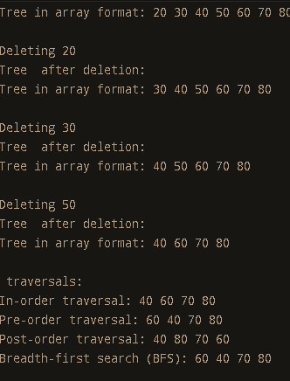
b) INSERTION ,DELETION AND TRAVERSAL OF THREADED BINARY TREE
#include <iostream>
#include <vector>

struct Node {
int data;
Node* left;
Node* right;
bool isThreaded; // true if this pointer is a thread

Node(int val) : data(val), left(nullptr), right(nullptr), isThreaded(false) {}
};

class ThreadedBinaryTree {
public:
Node* root;

ThreadedBinaryTree() : root(nullptr) {}

// Function to insert a new node with given data
void insert(int data) {
if (!root) {
root = new Node(data);
return;
}

Node* current = root;
Node* parent = nullptr;
while (current) {
parent = current;
if (data < current->data) {
current = current->left;
} else {
current = current->right;
}
}

Node* newNode = new Node(data);
if (data < parent->data) {
parent->left = newNode;
newNode->right = parent; // Create a thread to the parent
newNode->isThreaded = true;
} else {
parent->right = newNode;
newNode->right = nullptr; // Right child is null
}
}

// Simplified deletion logic (not a complete implementation)
void deleteNode(int data) {
std::cout << "Attempting to delete " << data << " (deletion not implemented).\n";
}

// Function to print the tree in array format
void printArray() {
std::vector<int> arr;
fillArray(root, arr);
std::cout << "Tree in array format: ";
for (int value : arr) {
std::cout << value << " ";
}
std::cout << std::endl;
}

// In-order traversal
void inOrder() {
std::cout << "In-order traversal: ";
Node* current = root;
while (current) {
// Go to the leftmost node
while (current->left) {
current = current->left;
}
std::cout << current->data << " ";

// If there is a thread, follow it
if (current->isThreaded) {
current = current->right;
} else {
current = current->right;
}
}
std::cout << std::endl;
}

// Pre-order traversal (using recursive method)
void preOrder(Node* node) {
if (node) {
std::cout << node->data << " ";
preOrder(node->left);
if (!node->isThreaded) {
preOrder(node->right);
}
}
}

// Wrapper for pre-order traversal
void preOrder() {
std::cout << "Pre-order traversal: ";
preOrder(root);
std::cout << std::endl;
}

// Post-order traversal (not typically used with threaded trees)
void postOrder(Node* node) {
if (node) {
postOrder(node->left);
if (!node->isThreaded) {
postOrder(node->right);
}
std::cout << node->data << " ";
}
}

// Wrapper for post-order traversal
void postOrder() {
std::cout << "Post-order traversal: ";
postOrder(root);
std::cout << std::endl;
}

private:
void fillArray(Node* node, std::vector<int>& arr) {
if (node) {
fillArray(node->left, arr);
arr.push_back(node->data);
fillArray(node->right, arr);
}
}
};

int main() {
ThreadedBinaryTree tbt;

// Insert nodes into the tree
tbt.insert(50);
tbt.insert(30);
tbt.insert(20);
tbt.insert(40);
tbt.insert(70);
tbt.insert(60);
tbt.insert(80);

std::cout << "Initial tree in array format:\n";
tbt.printArray();

// Perform deletions
int toDelete[] = {20, 30, 50};
for (int value : toDelete) {
std::cout << "\nDeleting " << value << "\n";
tbt.deleteNode(value);
std::cout << "Tree in array format after deletion:\n";
tbt.printArray();
}

// Display all traversals of the final tree after all deletions
std::cout << "\nFinal tree traversals:\n";
tbt.inOrder();
tbt.preOrder();
tbt.postOrder();

return 0;
}
OUTPUT:
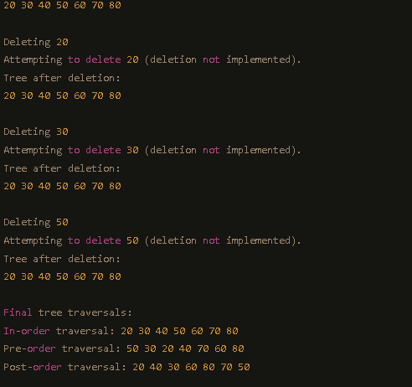

PROGRAM 10

Graph: Depth First and Breadth First traversal
#include <iostream>
#include <vector>
#include <queue>
#include <stack>
class Graph {
public:
// Constructor
Graph(int vertices) : vertices(vertices) {
adjList.resize(vertices);
}
// Function to add an edge to the graph
void addEdge(int src, int dest) {
adjList[src].push_back(dest);
adjList[dest].push_back(src); // For undirected graph
}

// Breadth-First Search (BFS)
void bfs(int start) {
std::vector<bool> visited(vertices, false);
std::queue<int> q;
visited[start] = true;
q.push(start);
std::cout << "BFS traversal: ";
while (!q.empty()) {
int node = q.front();
q.pop();
std::cout << node << " ";

for (int neighbor : adjList[node]) {
if (!visited[neighbor]) {
visited[neighbor] = true;
q.push(neighbor);
}
}
}
std::cout << std::endl;
}
// Depth-First Search (DFS)
void dfs(int start) {
std::vector<bool> visited(vertices, false);
std::cout << "DFS traversal: ";
dfsUtil(start, visited);
std::cout << std::endl;
}
private:
int vertices; // Number of vertices
std::vector<std::vector<int>> adjList; // Adjacency list

// Utility function for DFS
void dfsUtil(int node, std::vector<bool>& visited) {
visited[node] = true;
std::cout << node << " ";
for (int neighbor : adjList[node]) {
if (!visited[neighbor]) {
dfsUtil(neighbor, visited);
}
}
}
};

int main() {
Graph graph(7);
graph.addEdge(0, 1);
graph.addEdge(0, 2);
graph.addEdge(1, 3);
graph.addEdge(1, 4);
graph.addEdge(2, 5);
graph.addEdge(2, 6);
graph.bfs(0);
graph.dfs(0);
return 0;
OUTPUT
